Міністерство освіти і науки України
Національний університет “Львівська Політехніка”

Кафедра систем штучного інтелекту

Лабораторна робота №8
з дисципліни
«Об’єктно-орієнтоване програмування»

Виконав:
Студент групи КН-111
Кондрацький Владислав
Викладач:
Грабовська Н. Р.

Розробка графічного інтерфейсу користувача

Головний клас програми:

import java.io.File;
import java.io.IOException;
import java.util.prefs.Preferences;

import javax.xml.bind.JAXBContext;
import javax.xml.bind.Marshaller;
import javax.xml.bind.Unmarshaller;

import ch.makery.address.model.Person;
import ch.makery.address.model.PersonListWrapper;
import ch.makery.address.view.PersonEditDialogController;
import ch.makery.address.view.PersonOverviewController;
import ch.makery.address.view.RootLayoutController;
import javafx.application.Application;
import javafx.collections.FXCollections;
import javafx.collections.ObservableList;
import javafx.fxml.FXMLLoader;
import javafx.scene.Scene;
import javafx.scene.control.Alert;
import javafx.scene.control.Alert.AlertType;
import javafx.scene.layout.AnchorPane;
import javafx.scene.layout.BorderPane;
import javafx.stage.Modality;
import javafx.stage.Stage;

public class MainApp extends Application {

private Stage primaryStage;
private BorderPane rootLayout;
private ObservableList<Person> personData = FXCollections.observableArrayList();

@Override
public void start(Stage primaryStage) {
this.primaryStage = primaryStage;
this.primaryStage.setTitle("AddressApp");

initRootLayout();

showPersonOverview();
}

/**
* Initializes the root layout.
*/
public void initRootLayout() {
try {
// Load root layout from fxml file.
FXMLLoader loader = new FXMLLoader();
loader.setLocation(MainApp.class
.getResource("view/RootLayout.fxml"));
rootLayout = (BorderPane) loader.load();

// Show the scene containing the root layout.
Scene scene = new Scene(rootLayout);
primaryStage.setScene(scene);

// Give the controller access to the main app.
RootLayoutController controller = loader.getController();
controller.setMainApp(this);

primaryStage.show();
} catch (IOException e) {
e.printStackTrace();
}

// Try to load last opened person file.
File file = getPersonFilePath();
if (file != null) {
loadPersonDataFromFile(file);
}

}

/**
* Shows the person overview inside the root layout.
*/
public void showPersonOverview() {
try {
// Load person overview.
FXMLLoader loader = new FXMLLoader();
loader.setLocation(MainApp.class.getResource("view/PersonOverview.fxml"));
AnchorPane personOverview = (AnchorPane) loader.load();

// Set person overview into the center of root layout.
rootLayout.setCenter(personOverview);

// Give the controller access to the main app.
PersonOverviewController controller = loader.getController();
controller.setMainApp(this);

} catch (IOException e) {
e.printStackTrace();
}

}

/**
* Returns the main stage.
* @return
*/
public Stage getPrimaryStage() {
return primaryStage;
}

public static void main(String[] args) {
launch(args);
}
public MainApp() {
// Add some sample data
personData.add(new Person("Hans", "Muster"));
personData.add(new Person("Ruth", "Mueller"));
personData.add(new Person("Heinz", "Kurz"));
personData.add(new Person("Cornelia", "Meier"));
personData.add(new Person("Werner", "Meyer"));
personData.add(new Person("Lydia", "Kunz"));
personData.add(new Person("Anna", "Best"));
personData.add(new Person("Stefan", "Meier"));
personData.add(new Person("Martin", "Mueller"));
}
public ObservableList<Person> getPersonData() {
return personData;
}
public boolean showPersonEditDialog(Person person) {
try {
// Load the fxml file and create a new stage for the popup dialog.
FXMLLoader loader = new FXMLLoader();
loader.setLocation(MainApp.class.getResource("view/PersonEditDialog.fxml"));
AnchorPane page = (AnchorPane) loader.load();

// Create the dialog Stage.
Stage dialogStage = new Stage();
dialogStage.setTitle("Edit Person");
dialogStage.initModality(Modality.WINDOW_MODAL);
dialogStage.initOwner(primaryStage);
Scene scene = new Scene(page);
dialogStage.setScene(scene);

// Set the person into the controller.
PersonEditDialogController controller = loader.getController();
controller.setDialogStage(dialogStage);
controller.setPerson(person);

// Show the dialog and wait until the user closes it
dialogStage.showAndWait();

return controller.isOkClicked();
} catch (IOException e) {
e.printStackTrace();
return false;
}
}
public File getPersonFilePath() {
Preferences prefs = Preferences.userNodeForPackage(MainApp.class);
String filePath = prefs.get("filePath", null);
if (filePath != null) {
return new File(filePath);
} else {
return null;
}
}

/**
* Sets the file path of the currently loaded file. The path is persisted in
* the OS specific registry.
*
* @param file the file or null to remove the path
*/
public void setPersonFilePath(File file) {
Preferences prefs = Preferences.userNodeForPackage(MainApp.class);
if (file != null) {
prefs.put("filePath", file.getPath());

// Update the stage title.
primaryStage.setTitle("AddressApp - " + file.getName());
} else {
prefs.remove("filePath");

// Update the stage title.
primaryStage.setTitle("AddressApp");
}
}
public void loadPersonDataFromFile(File file) {
try {
JAXBContext context = JAXBContext
.newInstance(PersonListWrapper.class);
Unmarshaller um = context.createUnmarshaller();

// Reading XML from the file and unmarshalling.
PersonListWrapper wrapper = (PersonListWrapper) um.unmarshal(file);

personData.clear();
personData.addAll(wrapper.getPersons());

// Save the file path to the registry.
setPersonFilePath(file);

} catch (Exception e) { // catches ANY exception
Alert alert = new Alert(AlertType.ERROR);
alert.setTitle("Error");
alert.setHeaderText("Could not load data");
alert.setContentText("Could not load data from file:\n" + file.getPath());

alert.showAndWait();
}
}

/**
* Saves the current person data to the specified file.
*
* @param file
*/
public void savePersonDataToFile(File file) {
try {
JAXBContext context = JAXBContext
.newInstance(PersonListWrapper.class);
Marshaller m = context.createMarshaller();
m.setProperty(Marshaller.JAXB_FORMATTED_OUTPUT, true);

// Wrapping our person data.
PersonListWrapper wrapper = new PersonListWrapper();
wrapper.setPersons(personData);

// Marshalling and saving XML to the file.
m.marshal(wrapper, file);

// Save the file path to the registry.
setPersonFilePath(file);
} catch (Exception e) { // catches ANY exception
Alert alert = new Alert(AlertType.ERROR);
alert.setTitle("Error");
alert.setHeaderText("Could not save data");
alert.setContentText("Could not save data to file:\n" + file.getPath());

alert.showAndWait();
}
}
}

Запис в головне вікно:

import java.time.LocalDate;

import javax.xml.bind.annotation.adapters.XmlJavaTypeAdapter;

import ch.makery.address.util.LocalDateAdapter;
import javafx.beans.property.IntegerProperty;
import javafx.beans.property.ObjectProperty;
import javafx.beans.property.SimpleIntegerProperty;
import javafx.beans.property.SimpleObjectProperty;
import javafx.beans.property.SimpleStringProperty;
import javafx.beans.property.StringProperty;

/**
* Model class for a Person.
*
* @author Marco Jakob
*/
public class Person {

private final StringProperty firstName;
private final StringProperty lastName;
private final StringProperty street;
private final IntegerProperty postalCode;
private final StringProperty city;
private final ObjectProperty<LocalDate> birthday;

/**
* Default constructor.
*/
public Person() {
this(null, null);
}

/**
* Constructor with some initial data.
*
* @param firstName
* @param lastName
*/
public Person(String firstName, String lastName) {
this.firstName = new SimpleStringProperty(firstName);
this.lastName = new SimpleStringProperty(lastName);

// Some initial dummy data, just for convenient testing.
this.street = new SimpleStringProperty("some street");
this.postalCode = new SimpleIntegerProperty(1234);
this.city = new SimpleStringProperty("some city");
this.birthday = new SimpleObjectProperty<LocalDate>(LocalDate.of(1999, 2, 21));
}

public String getFirstName() {
return firstName.get();
}

public void setFirstName(String firstName) {
this.firstName.set(firstName);
}

public StringProperty firstNameProperty() {
return firstName;
}

public String getLastName() {
return lastName.get();
}

public void setLastName(String lastName) {
this.lastName.set(lastName);
}

public StringProperty lastNameProperty() {
return lastName;
}

public String getStreet() {
return street.get();
}

public void setStreet(String street) {
this.street.set(street);
}

public StringProperty streetProperty() {
return street;
}

public int getPostalCode() {
return postalCode.get();
}

public void setPostalCode(int postalCode) {
this.postalCode.set(postalCode);
}

public IntegerProperty postalCodeProperty() {
return postalCode;
}

public String getCity() {
return city.get();
}

public void setCity(String city) {
this.city.set(city);
}

public StringProperty cityProperty() {
return city;
}

@XmlJavaTypeAdapter(LocalDateAdapter.class)
public LocalDate getBirthday() {
return birthday.get();
}

public void setBirthday(LocalDate birthday) {
this.birthday.set(birthday);
}

public ObjectProperty<LocalDate> birthdayProperty() {
return birthday;
}
}

fxml файл головного вікна:

<?xml version="1.0" encoding="UTF-8"?>

<?import javafx.scene.control.Button?>
<?import javafx.scene.control.ButtonBar?>
<?import javafx.scene.control.Label?>
<?import javafx.scene.control.SplitPane?>
<?import javafx.scene.control.TableColumn?>
<?import javafx.scene.control.TableView?>
<?import javafx.scene.layout.AnchorPane?>
<?import javafx.scene.layout.ColumnConstraints?>
<?import javafx.scene.layout.GridPane?>
<?import javafx.scene.layout.RowConstraints?>

<AnchorPane prefHeight="300.0" prefWidth="600.0" xmlns:fx="http://javafx.com/fxml/1" xmlns="http://javafx.com/javafx/8.0.171">
<children>
<SplitPane dividerPositions="0.29797979797979796" prefHeight="300.0" prefWidth="600.0" AnchorPane.bottomAnchor="0.0" AnchorPane.leftAnchor="0.0" AnchorPane.rightAnchor="0.0" AnchorPane.topAnchor="0.0">
<items>
<AnchorPane minHeight="0.0" minWidth="0.0" prefHeight="160.0" prefWidth="100.0">
<children>
<TableView layoutX="-12.0" prefHeight="298.0" prefWidth="200.0" AnchorPane.bottomAnchor="0.0" AnchorPane.leftAnchor="0.0" AnchorPane.rightAnchor="0.0" AnchorPane.topAnchor="0.0">
<columns>
<TableColumn prefWidth="86.5" text="Name" />
</columns>
<columnResizePolicy>
<TableView fx:constant="CONSTRAINED_RESIZE_POLICY" />
</columnResizePolicy>
</TableView>
</children>
</AnchorPane>
<AnchorPane minHeight="0.0" minWidth="0.0" prefHeight="259.0" prefWidth="390.0">
<children>
<GridPane layoutX="14.0" layoutY="22.0" prefHeight="200.0" prefWidth="407.0" AnchorPane.leftAnchor="5.0" AnchorPane.rightAnchor="5.0" AnchorPane.topAnchor="30.0">
<columnConstraints>
<ColumnConstraints hgrow="SOMETIMES" minWidth="10.0" prefWidth="100.0" />
<ColumnConstraints hgrow="SOMETIMES" minWidth="10.0" prefWidth="100.0" />
</columnConstraints>
<rowConstraints>
<RowConstraints minHeight="10.0" prefHeight="30.0" vgrow="SOMETIMES" />
<RowConstraints minHeight="10.0" prefHeight="30.0" vgrow="SOMETIMES" />
<RowConstraints minHeight="10.0" prefHeight="30.0" vgrow="SOMETIMES" />
<RowConstraints minHeight="10.0" prefHeight="30.0" vgrow="SOMETIMES" />
<RowConstraints minHeight="10.0" prefHeight="30.0" vgrow="SOMETIMES" />
<RowConstraints minHeight="10.0" prefHeight="30.0" vgrow="SOMETIMES" />
</rowConstraints>
<children>
<Label text="Name" />
<Label text="Label" GridPane.columnIndex="1" />
<Label text="Label" GridPane.rowIndex="1" />
<Label text="Label" GridPane.columnIndex="1" GridPane.rowIndex="1" />
<Label text="Label" GridPane.rowIndex="2" />
<Label text="Label" GridPane.columnIndex="1" GridPane.rowIndex="2" />
<Label text="Label" GridPane.rowIndex="3" />
<Label text="Label" GridPane.columnIndex="1" GridPane.rowIndex="3" />
<Label text="Label" GridPane.rowIndex="4" />
<Label text="Label" GridPane.columnIndex="1" GridPane.rowIndex="4" />
<Label text="Label" GridPane.rowIndex="5" />
<Label text="Label" GridPane.columnIndex="1" GridPane.rowIndex="5" />
</children>
</GridPane>
<Label text="Film Details" AnchorPane.leftAnchor="5.0" AnchorPane.topAnchor="5.0" />
<ButtonBar layoutX="138.0" layoutY="244.0" prefHeight="40.0" prefWidth="200.0">
<buttons>
<Button mnemonicParsing="false" text="New" />
<Button mnemonicParsing="false" text="Edit" />
<Button mnemonicParsing="false" text="Delete" />
</buttons>
</ButtonBar>
</children>
</AnchorPane>
</items>
</SplitPane>
</children>
</AnchorPane>

Головне вікно:

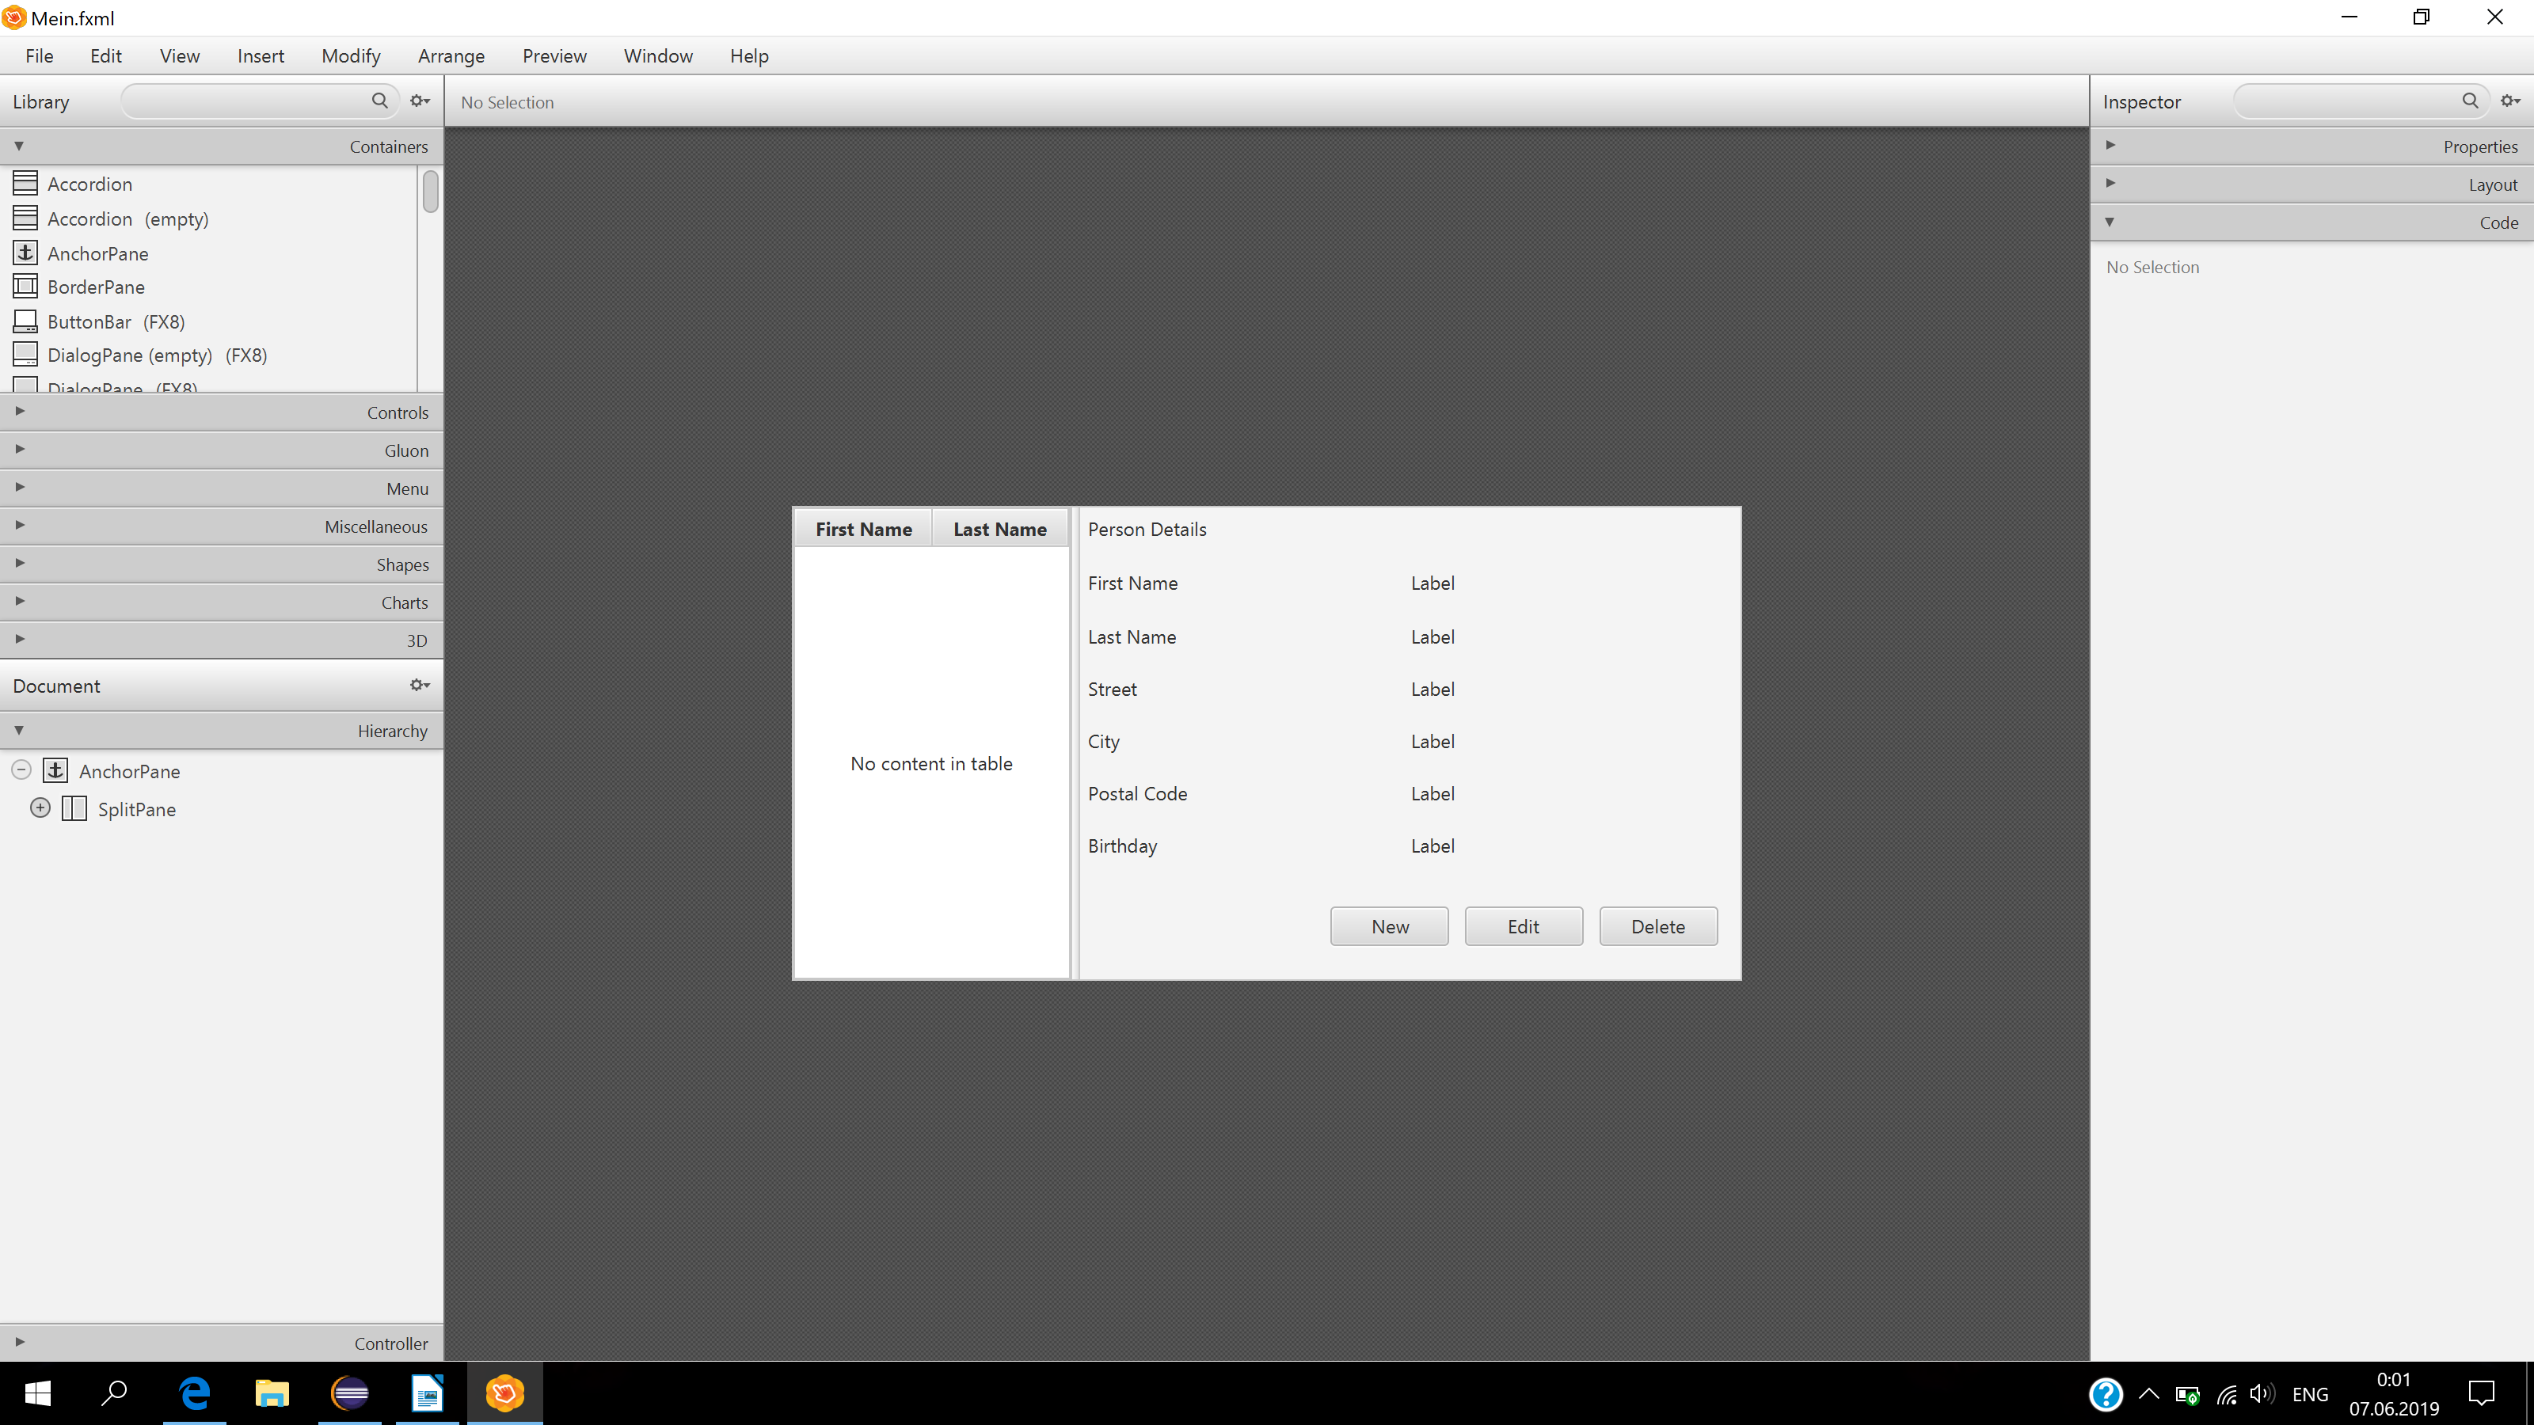
Вікно запису людей:

